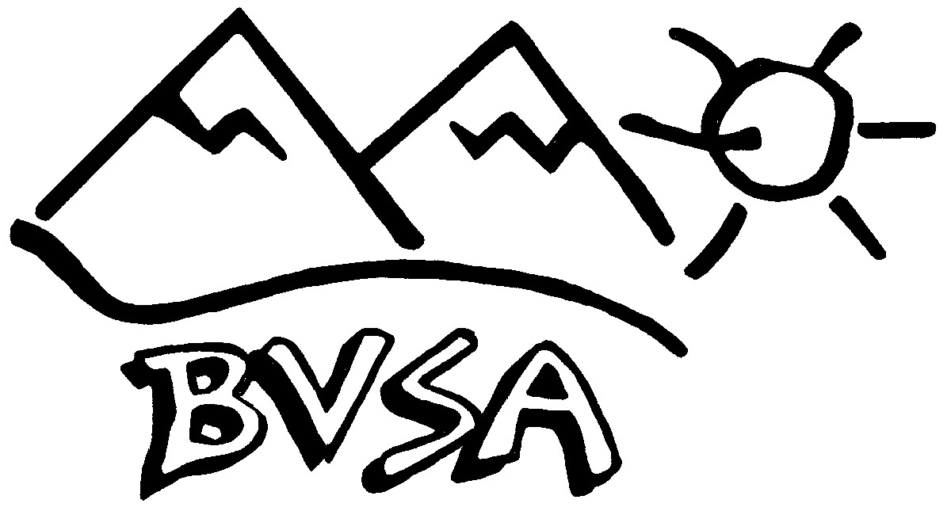
BRANDYWINE VALLEY SKI ASSOCIATION
MEMBERSHIP/RENEWAL APPLICATION
MAIL TO:

BVSA, P.O. BOX 549
DOWNINGTOWN, PA 19335-0549
The BVSA newsletter is delivered by email only, so please make sure your email address is correct. If you do not have access to email, please contact the BVSA VP to see if other arrangements can be made.
Please check the box if you do not want your information published in the directory 
Address change? Yes  No  |  |  | ⇨ Home Phone
⇨ Name(s) |  |  | ⇨ Cell Phone
⇨ Children |  |  | ⇨ Preferred Email
⇨ Address |  |  | ⇨ Spouse Cell
City | State | Zip Code | ⇨ Spouse Preferred Email
The Brandywine Valley Ski Association (BVSA) is a year-round sports/social club providing a variety of activities. Most of the activities are, to varying degrees, hazardous. By making this application for membership, I voluntarily assume the risks involved. By assuming all risks involved, I agree not to hold BVSA, its officers, board members, or agents liable for any accident or injury resulting from my participation in a club activity. After reading and understanding this release of liability, I hereby apply for membership in the Brandywine Valley Ski Association.
Signature of Applicant |  |  |  | Date
Signature of Spouse/Significant Other |  |  |  | Date
The membership year runs from November 1 to October 31. New and renewal membership forms/payments received June 1 through October 31 will be paid through to the following year. November 1 to November 15 acts as a grace period for the late fee. For example, if you pay your dues on November 3, you are paying for the current year.
Membership Fees  Individual $ 25.00 $ ______  Couple $ 30.00 $ ______  Family $ 35.00 $______ Initiation Fee (if you were not a $ 5.00 $______ member last year) OR  Late Fee After November 15 Total $______ |  |  |  | BVSA ONLY  Date Paid Check No. Cash  Amount  Date Deposit Entered into database
How did you hear about BVSA?  ⇨ Pamphlet  ⇨ Newspaper  ⇨ Internet – Web Page  ⇨ Referred by _____________________  Other ______________________________________ |  |  |  | Would you like to assist with?  ⇨ Meeting Speaker/Activity  ⇨ Board/Activity positions  ⇨ Non-skiing Activity  ⇨ The Newsletter  ⇨ The Directory  ⇨ Public Relations  ⇨ Ski Trips  ⇨ Non-Ski Trips

Revised 2/9/19

